**FINAL EXAM**

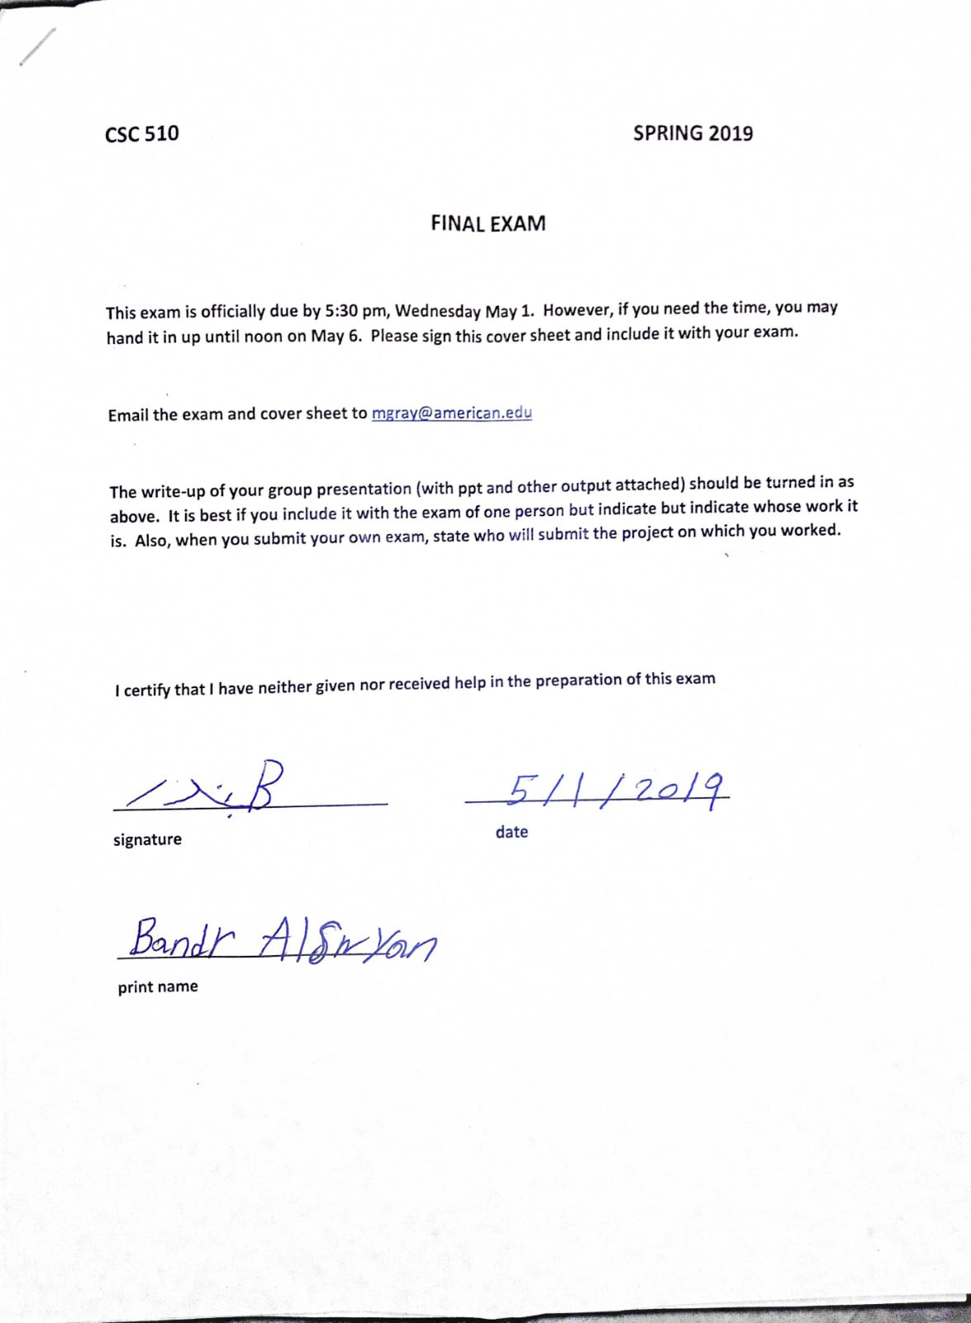

**Question One**

1. **Legal but Unethical Issues**

As a businessman and business developer professional, different instances arise where some activities and acts are legal but are never ethical in society. Labor practices have for years been the leading area where ethical concerns have always been raised. The labor laws are known to lag behind different sentiments creating room for many companies and organizations to employ practices which their customers find them unethical. One of the many examples is when companies or organizations pay minimum wage to their full-time staff. Minimum wage is legal and is set by the employer and the employee who agree on one by setting terms and conditions for its implementation (Hughes, 2018). However, those employees working for minimum wage find it challenging to meet their daily expenses and to meet the basic needs of their families. This leads them in debt and later become bitter with their employers. The employers according to the law are act legally, but the employees do not look at the issue in legal terms but, they see the issue as unethical. This is the leading cause of staff strikes in many organizations where the staff demand for a pay rise. The employer is always likely to win the case if the matter is taken to court.

Another common issue is on environmental concerns. Any government in the world has put burdensome regulations on industries whose activities cause direct environmental impact. These laws and regulations cannot all fulfill the communities that live around the industries or beyond. A good example is the companies that are involved in oil drilling operations that started from the beginning of the 21st century. The hydraulic fracturing process that they use was legalized starting from April 2013 (Hughes, 2018). However, these companies always face calls for legal actions and protests from the communities around them claiming that their activities have a direct environmental impact. They see the companies as unethical, but on the other hand, the companies always operate legally following all legal laws and regulations (Hughes, 2018). Finally, another area that is faced with a challenge of legal and ethical issues is in marketing. Some companies take advantage of the uneducated people in the community and lure them into buying a specific product at a high price. This is acceptable in the law, especially in a free market economy where the price of a product depends on supply and demand. Ethically, this is taking advantage of others.

1. **Ethical but illegal issues**

Companies are applying every means possible to make profits due to the high level of competition in almost every industry. Some of the activities the companies involve themselves in may be ethically correct but according to the law are considered as illegal. Some of the examples include when a bank is lending money to its customers. Before giving the customer a loan, banks have to carry out predatory lending. Mainly, banks give a loan if the customer has collateral like a house or a piece of land. In an instance when the customer default to pay the loan, the bank will never go at a loss but will still benefit by selling the collateral. Some deceive the customer of giving them low interests rates on loan, but in the real sense, it is always higher than what they reveal to the customer who may end up having challenges to pay back. Most of them use loans as an avenue through which they can own the customer's properties which they place as the collateral for the loan.

Another area is where patients in the hospital are taken advantage of the doctors. Whenever one visits a hospital, money has to change hands to receive services from a doctor or a dentist. Some doctors recommend expensive procedures or medications to patients that may not be necessary. Some actually ensure that the procedures are always expensive and never disclose to the patents of alternatives that are affordable but effective. Most of them do this to benefit from huge payments that the patient's insurance companies will pay or from some government agencies.

Vendors who deal with second-hand products such as cars also indulge themselves in ethical activities which are usually illegal. For example, when one is purchasing a used car, the dealer may not reveal instances where the car was damaged or involved in an accident at some point. They do so to ensure they get more money from the deal. According to the law, someone selling a product should disclose every information regarding the product (Tsikerdekis & Zeadally, 2015). A final example is when a contract is not fulfilled. It is always illegal for a person or a company not to fulfill a contract. However, one can give logical reasons why the contract was not fulfilled which are ethical but whichever the reasons, this is illegal according to the law (Torres et al., 2018).

**Question 2: Protecting intellectual property by patent**

A patent can be defined as a legal right given to the owner of an intellectual property which excludes other people from using, making, selling or even importing the invention made for a specific period of time which is usually twenty years. The patent rights mainly fall under civil laws and the patent holder have a right to sue anyone who may infringe the patent. To get a patent in the United States, one has to fill a patent application form with the United States Patent and Trademark Office (USPTO) (Fang et al., 2017). To ensure that my innovation is well protected, I have to apply for a patent. There are three types of patents which are utility patent, design patent and plant patent. My innovation falls under utility patent, which is the most common and broadly covers processes, article of manufacture, machines, improvements made on products among others. The process of a patent application can be complicated and costly and sometimes can take a lot of time but to ensure I follow all the required legal procedures; I have to hire an attorney to file my patent application. There are many different merits that li will have to enjoy once my invention is patent protected.

The first advantage is that a patent prevents theft of any innovation made. For any unpatented innovation made, it is straightforward for the invention to be stolen from the actual owner and legally become another person's property. This mainly happens when the inventor shares the innovation with potential investors or licensee who have to evaluate the innovation first before investing in it. Most of them turn down the innovation but turn around and file a patent application on the invention without the knowledge of the owner. Later when the owner applies for the patent, he or she finds that someone else has already applied that the invention is already stolen. A patent is only given to one person or organization which files for the patent application first. Anyone coming after is considered as theft. By receiving a patent for my innovation, I believe no one will be in a position to claim the ownership of the innovation apart from me.

The second advantage is that the patent will help me make higher profit margins. A patent allows the owner of the innovation to exclude other people from using, selling, making, importing or exporting and offering for sale the innovation. Since the innovation has a high market demand and no competitor, the prices of the innovation will be slightly high hence more profit margin. This will be the case for a specific period which is usually twenty years according to the law. This will give me room to be perfect on the innovation and gain resources to come up with better innovations.

The third merit of my innovation being patented is that it reduces the level of competition. A patent allows the owner creating a barrier to entry hence keeping competitors away. Any competitor thinking of infringing the patent may way the rewards to be gained against the risks involved. Mainly the risks of patent infringement are always more compared to the advantage or the profits that are likely to be gained once it is discovered. The fourth advantage is that patent encourages settlement. Sometimes it happens that somebody else happened to have a similar innovation. During litigation, no one can accept that they have been involved in patent infringement and this can make the patent nullified. To avoid such a scenario, patent laws allow that the two parties can come up with an agreement to see the two licenses are merged and become one innovation. This ensures that both parties benefit other than losing it altogether.

The fifth advantage of my innovation being patented is that the market share can be expanded. Once the innovation is patented, it is possible that I can license the innovation to other companies or individuals in different geographic locations and markets. This will provide me with regular loyalty payment paid after a specific agreed period of time for those using the innovation or selling the innovation on my behalf. In addition to that, the patent innovation can be licensed to other fields like education, medical field. This expands the market share for innovation (Fang et al., 2017). The sixth advantage is that the innovation doesn’t have to be kept a secret once it is patented. Unlike trade secrets that require the innovation always to be made secrete which is challenging to ensure the information about the innovation does not leak. Patent ensures that anyone who develops a similar innovation does it illegally no matter whether they know every detailed information about the innovation and how it is developed. This gives me peace of mind at all times knowing that the innovation is always protected.

**Question 3: American University Computer Use and Copyright Policy**

The American University Computer Use and Copyright Policy is quite an important document that shows different activities that are prohibited in the university’s computer laboratory. I think the twelve provisions is objectionable and needs to be reviewed. The provision states that student or staff should always refrain from using the university resources for commercial reasons or for personal gains. Bearing in mind that students pay fees to the university to access services and resources, the provision puts a limit for this which should not be the case. Students should be allowed, especially those taking business-related courses, to develop their entrepreneurial skills by utilizing the university's laboratory resources for commercial reasons. This is part of learning where the students can practically implement what they learn in class.

Students also taking other courses should be allowed to utilize the university resources to develop entrepreneurial skills also. Students should be allowed to use the university’s computer services for commercial purposes or personal purposes. This should be so to motivate them to come up with innovative business ideas. Young students including Mike Zuckerberg developed business ideas like Facebooks. The university should offer its computer resources for students to be innovative and come up with such ideas since students have limited resources to do so on their own. The university will be playing a part in reducing the level of unemployment in the country and motivating students to be job creators and not job seekers as it has been the norm for years.

The computer use and copyright policy should incorporate a modern security feature that the privacy of the users can never be compromised in any way. From the provisions provided, it is clear that a person can disclose their password to a different person to access the universities computer services. One can also access another person's information without their consent. This can happen, and the university may never know or detect it. To ensure this is curbed the university should adopt a more secure way where the computer users should use facial recognition devices. The user's details and faces should are fed in the system, and whenever one needs to access the computer services, the system will mandate them to provide the password which should match with their face. In case of any mismatch that might arise between the password and the face of the user, an alarm should be raised to the computer lab personnel, and the intruder identified.

**Question 4: Decision Making**

Decision making contributes a lot to the success or failure of a company or an organization. Good decisions can propel the company or organization forward while poor decisions can be the starting point of a company’s or organization’s downfall. However, it is worse not to make decisions since there is always a better side of any decision made unlike no decision made at all. For any decision to be made, there are four steps that have to be followed. The first step is to identify the decision. This is where one needs to know when a specific decision needs to be made and defining the nature of the decision clearly.

The second step is gathering enough information relevant to the decision being made. Thirdly is the identification of different available alternatives. This is done after the information is gathered and different alternatives and paths likely to be followed listed. The fourth step is weighing the evidence. This can be made based on personal emotions, the impact of the decision among other factors. The fifth step is choosing an alternative among the listed ones based on the first four steps of decisions making. The sixth step is taking action which is done once a person, a group or a company is ready. The action is always based on the chosen alternative. The seventh and final step is carrying out a review on the decision already made (Heyler et al., 2016). As a businessman and business developer professional, I am always mandated to make decisions for the companies that I lead. This decision can have a positive or negative impact on my profession and more on the companies which look up to me for advice and my companies that I also own and manage. There are quite many decisions I make that bring positive impact to the companies and this also positively affects my profession. The first important decision is the involvement of employees in strategic planning and in the decision making the process.

This is one of the crucial decisions that I have always made for years. The executives, workers, managers and other stakeholders have valuable insights that give shape to policies and procedures that when combined form the company’s strategy for competitive advantage and growth. The company staff always know the company best and therefore are a great source of insights in various operations. This also makes the employees feel considered as one of the great stakeholders in the company and therefore become loyal to see it successful. The success of the company reflects a high level of professionalism, and this positively affects my profession. However, this can also negatively the company as well as my profession if there is too much employee involvement. This creates mistrust and confusion between the management and the employees leading to failure.

Another crucial decision that affects my professionalism positively is on outsourcing. Outsourcing is giving a third-party company the responsibility to conduct critical function or functions of a company on behalf of the company. This is a crucial decision that as a professional I need to ensure the right and competitive companies have been given the responsibility to conduct the Information Technology services of the different companies that I offer professional business guidance services as well as those I own as a businessman. Outsourcing is a deliberate decision that as a leader have to take to bring change and growth as well as improving the services offered to customers. Outsourcing ensures that companies focus on what they do best. The decision of outsourcing of IT services is likely to bear positive fruits to the companies and at the same time positively affecting my reputation as a professional.

The third critical decision that can affect my profession is conducting all my activities pertaining to my profession ethically. As a businessman and business developer professional, I am also a leader. I understand very well that if a leader is unethical, the same spirit trickled down to the staff and the rest of the people in the company. The decision to always be involved in ethical activities have must have a positive effect on my professional reputation and to the companies where I lead. One of the impacts is that there will be a high level of employee performance and attitude. As a leader, it is always right to lead by example. Once I am ethical in all my activities and dealings with the employee, the chances of the employees improving in their performance and developing a positive attitude towards the business are very high. This also leads to the creation of good quality and productive leader-employee relations. The second outcome is the creation of favorable perception towards the company. Customers and the employees must develop a positive perception of the company, and this also builds confidence and also strengthens customers' and employees' loyalty. Finally, deciding on conducting all activities ethically evades legal related issues and problems. Most unethical activities are always illegal. Ensuring that I hold all my activities ethically will always ensure I don’t go against the laws and regulations set. By doing so, it is also a way of ensuring that professional reputation is always protected.

The fourth decision that can significantly affect my professionalism is regarding being involved in corrupt activities. Corruption is a vice that has affected many professionals, companies, and countries. However, I believe that those who engage themselves in corruption is as a result of choice made. Choices always have consequences which can be positive or negative. Bing involved in corrupt activities can significantly affect my professional negatively. The companies that I lead can also be significantly affected since corruption leads to misappropriation of company funds and resources as well as going against the rights of the employees and other stakeholders. As a professional, corruption can lead to mistrust from my clients and ruined my reputation. It can also lead to the rise of legal cases where my professionalism can be significantly affected.

Lastly, the decision to follow shortcuts in various professional and business activities can adversely affect the reputation of the companies as well as that of my professionalism. It has always been said that short cuts are still long. Once shortcuts are followed in various activities like in decision making, this will always lead to the rise of unforeseen challenges and obstacles that could be easily identified if the right process was followed. Shortcuts can also be supported in obtaining various legal documentation. Once the government realizes this, there is a high chance of the companies being closed or legal actions being taken against the companies and me involved. Professionally, once one acquires professional documents illegally, it is considered as a crime and can be sued in a court of law for professional malpractices. However, this is mainly based on one’s choice to follow the right direction or to follow the short cut. Shortcuts have always been the source of professional or companies' failure. It is the responsibility of every profession in any category to ensure the decisions made are still right. Everyone can make the right decisions. We have the power to control our decisions, but we may not have equal power to control the outcomes of the decisions made. Right choices lead to the right results.

**Question 5: Recommendation for Ethical Conduct**

Data science career raises numerous ethical concerns for many companies and organizations. For one starting a career in data analysis, it is crucial to understand several ethical practices to avoid compromising the authenticity of the company or organization they might work for in future and at the same time practicing themselves from going against different laws and regulations. The first and one of the most important ethical conducts is to ensure that all customer’s data, as well as the identity, remain as private as possible. The term private here does not mean that it should be kept secret but what this means is that customers’ information should not be disclosed to an unauthorized person or people for use without the consent of the owner.

The second ethical conduct is that when coming up with different algorithms in machines like computers, it is crucial to come up with algorithms that are not biased. Some companies have institutionalized their data based on biased algorithms (Mathies, 2018). This could be based on racism or sexism where customers or employees of a specific race are separated from others from a certain race or sex. This is unethical and should be discouraged especially in the twenty-first century where people are more sensitive on unethical and bias companies. The third ethical conduct is to ensure that the confidential data that has been shared by the customers or employees in the organization or company they might be working for is treated as confidential (Mathies, 2018). People disclose important and personal information regarding their medical status, financial status and their location among others. This information should always be treated as confidential, and a lot of care should be taken on how the information is shared further.

The fourth ethical conduct to avoid conflict of interest. This is where a data scientist provides his or her services to a company with a hidden agenda for personal gain. This is quite risky both to the company and to the data scientist. An example is when a data scientist discloses some critical company data to a competitor in exchange for some payments. This place the company in a risky position, and at the same time, a data scientist can face the company or federal law for his or her conducts (Mathies, 2018). The fifth ethical conduct for a data scientist is to ensure that he or she always provides highly competent data science services with the highest level of professionalism. This is through demonstration of the high level of skills, knowledge and adequate preparation.

References

Fang, L. H., Lerner, J., & Wu, C. (2017). Intellectual property rights protection, ownership, and innovation: Evidence from China. *The Review of Financial Studies*, *30*(7), 2446-2477.

Heyler, S. G., Armenakis, A. A., Walker, A. G., & Collier, D. Y. (2016). A qualitative study investigating the ethical decision-making process: A proposed model. *The Leadership Quarterly*, *27*(5), 788-801.

Hughes, C. (2018). *Ethical and legal issues in human resource development: Evolving roles and emerging trends*. Sprin

Mathies, C. (2018). The Ethical Use of Data. *New Directions for Institutional Research*, *2018*(178), 85-97.

Torres, A., Desai, T., Desai, A., Kirby, W. T., & Locke, M. C. (2018). Ethical Issues. In *Lasers in Dermatology and Medicine* (pp. 493-497). Springer, Cham.

Tsikerdekis, M., & Zeadally, S. (2015). Detecting and preventing online identity deception in social networking services. *IEEE Internet Computing*, *19*(3), 41-49.